**ABSTRACT**

The interest in virtualization has been growing rapidly in the IT industry because of inherent benefits like better resource utilization and ease of system manageability. In this we use desktop virtualization which is a concept of separating the logical desktop from physical machine. The experimentation and use of virtualization as well as the simultaneous deployment of virtual software are increasingly getting popular . In this context, we discuss various aspects of virtualization – starting from the working principle of virtual machines, installation procedure for a virtual guest operating system on a physical feasible enough to be conducted in a physical network of personal computers; but could host operating system, virtualization options and a performance study measuring the throughput obtained on a network of virtual machines and physical host machines. In addition, this project evaluates the use of virtual network to provide a connection between different virtual machines using Azure account.

**KEYWORDS**: Virtualization, Virtual machines, Virtual network, Azure Active Directory.

**EXISTING SYSTEM**

In order to provide connection between different machines over a network, a physical medium is required. Peer- to-Peer network is created when two or more PCs are connected and share resources without going through a separate server computer.

**Drawbacks**

* Time consuming
* Very insecure
* Data recovery and backup is very difficult.

**PROPOSED SYSTEM**

Virtual network is a technology that facilitates the control of one or more remotely located computers or servers over the internet .Data can be stored and retrieved, software can be run and peripherals can be operated through a web browser as if the distinct hardware were onsite. A virtual machine is not a physical machine but software that offers an application a logical central processing unit and logical memory and storage capacity.

**Advantages**

* Reduced workload
* Costs are predictable
* Cheaper
* Faster deployment of resources.

**INTRODUCTION**

**AZURE VIRTUAL NETWORK**

Azure Virtual Network enables many types of Azure resources, such as Azure Virtual Machines (VM), to securely communicate with each other, the internet, and on-premises networks. Azure Virtual Network provides the following key capabilities:

**Isolation and segmentation**

You can implement multiple virtual networks within each azure subscription and azure region. Each virtual network is isolated from other virtual networks. For each virtual network you can:

* Specify a custom private IP address space using public and private addresses. Azure assigns resources in a virtual network a private IP address from the address space that you assign.
* Segment the virtual network into one or more subnets and allocate a portion of the virtual network's address space to each subnet.
* Use Azure-provided name resolution, or specify your own DNS server, for use by resources in a virtual network.

**Communicate with the internet**

All resources in a virtual network can communicate outbound to the internet, by default. You can communicate inbound to a resource by assigning a public IP address to it.

**Communicate between Azure resources**

Azure resources communicate securely with each other in one of the following ways:

* **Through a virtual network**: You can deploy VMs, and several other types of Azure resources to a virtual network, such as Azure App Service Environments and Azure Virtual Machine Scale Sets. To view a complete list of Azure resources that you can deploy into a virtual network, see virtual network service integration.

# Create a virtual network using the Azure portal

A virtual network enables Azure resources, such as virtual machines (VM), to communicate privately with each other, and with the internet. In this first we need to create a virtual network. After creating a virtual network, you deploy two VMs into the virtual network. You then connect to one VM from the internet, and communicate privately between the two VMs.

If you don't have an Azure subscription, create a **free account** before you begin.

## Log in to Azure

Log in to the Azure portal at [https://portal.azure.com](https://portal.azure.com/).

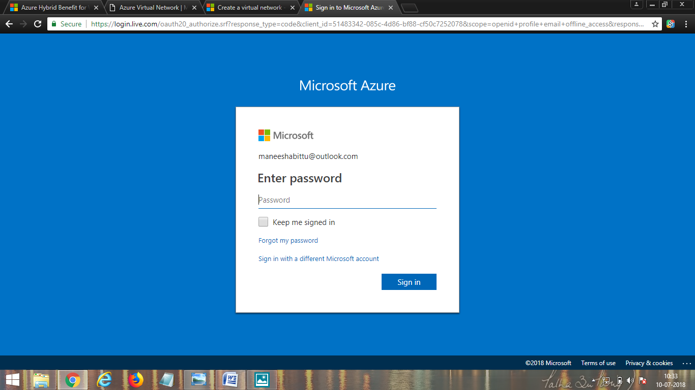

## Create a virtual network

1. Select **+ Create a resource** on the upper, left corner of the Azure portal.
2. Select **Networking**, and then select **Virtual network**.
3. Enter, or select, the following information, accept the defaults for the remaining settings, and then select **Create**:

* **Name**: The name must be unique in the **resource group** that you select to create the virtual network in. You cannot change the name after the virtual network is created. You can create multiple virtual networks over time.
* **Address space**: The address space for a virtual network is composed of one or more non-overlapping address ranges that are specified in CIDR notation. The address range you define can be public or private . Whether you define the address range as public or private, the address range is reachable only from within the virtual network, from interconnected virtual networks, and from any on-premises networks that you have connected to the virtual network.
* Although you can define only one address range when you create the virtual network, you can add more address ranges to the address space after the virtual network is created. To learn how to add an address range to an existing virtual network, **see add or remove address range.**
* **Subnet name**: The subnet name must be unique within the virtual network. You cannot change the subnet name after the subnet is created. The portal requires that you define one subnet when you create a virtual network, even though a virtual network isn't required to have any subnets. In the portal, you can define only one subnet when you create a virtual network. You can add more subnets to the virtual network later, after the virtual network is created. To add a subnet to a virtual network, see Manage subnets. You can create a virtual network that has multiple subnets by using Azure CLI or PowerShell.
* **Subnet address range**: The range must be within the address space you entered for the virtual network. The smallest range you can specify is /29, which provides eight IP addresses for the subnet. Azure reserves the first and last address in each subnet for protocol conformance. Three additional addresses are reserved for Azure service usage. As a result, a virtual network with a subnet address range of /29 has only three usable IP addresses. If you plan to connect a virtual network to a VPN gateway, you must create a gateway subnet. Learn more about specific address range considerations for gateway subnets. You can change the address range after the subnet is created, under specific conditions. To learn how to change a subnet address range, see Manage subnets.
* **Subscription**: Select a subscription. You cannot use the same virtual network in more than one Azure subscription. However, you can connect a virtual network in one subscription to virtual networks in other subscriptions with virtual network peering. Any Azure resource that you connect to the virtual network must be in the same subscription as the virtual network.
* **Resource group**: Select an existing resource group or create a new one. An Azure resource that you connect to the virtual network can be in the same resource group as the virtual network or in a different resource group.
* **Location**: Select an Azure location, also known as a region. A virtual network can be in only one Azure location. However, you can connect a virtual network in one location to a virtual network in another location by using a VPN gateway. Any Azure resource that you connect to the virtual network must be in the same location as the virtual network.

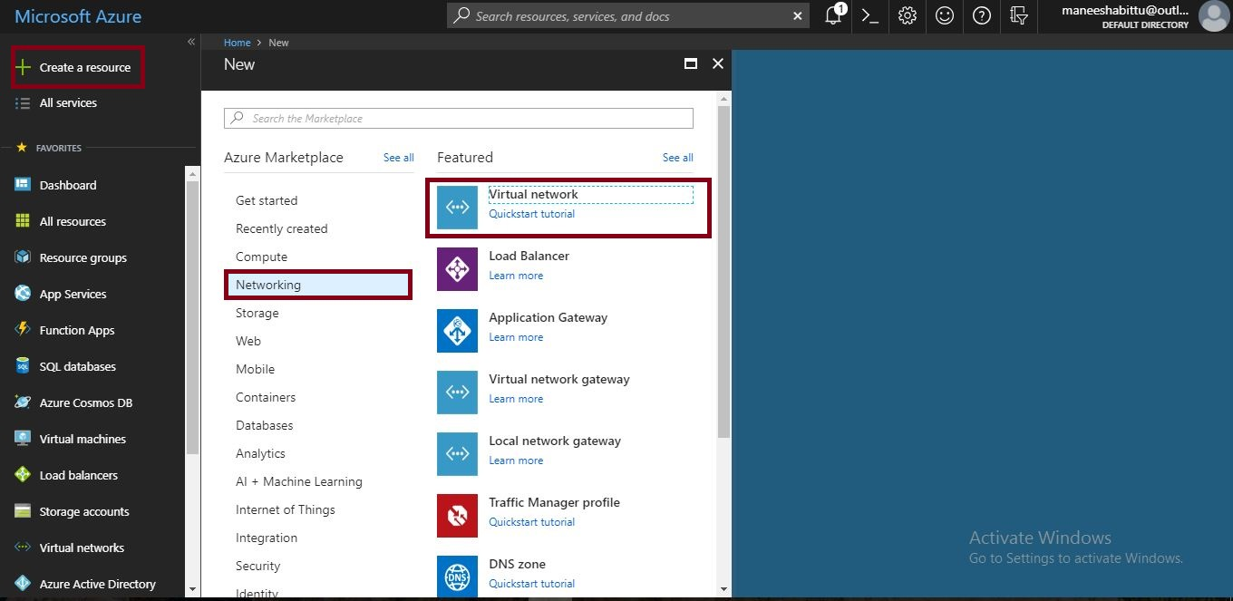

| **Settings** | **Value** |
| --- | --- |
| Name | Vnet |
| Subscription | Free trail account. |
| Address space | Default |
| Resource group | Select **Create new** and enter myrg1. |
| Location | Select **WEST US2**. |
| Subnet | Default |
| Address range | 10.0.0.0/24 |
| DDos protection | Basic |
| Service endpoints | Disabled |

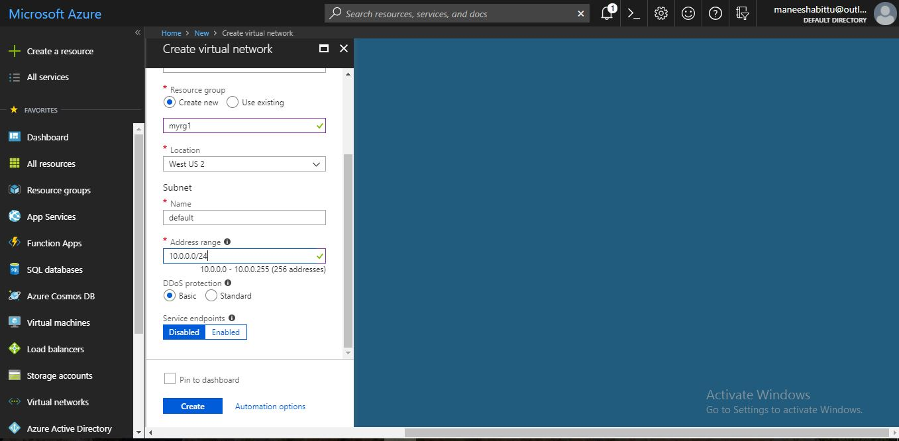

1. Enter the following values on the Create virtual network (resource manager) panel and then click **Create.**

5.Virtual network is created.

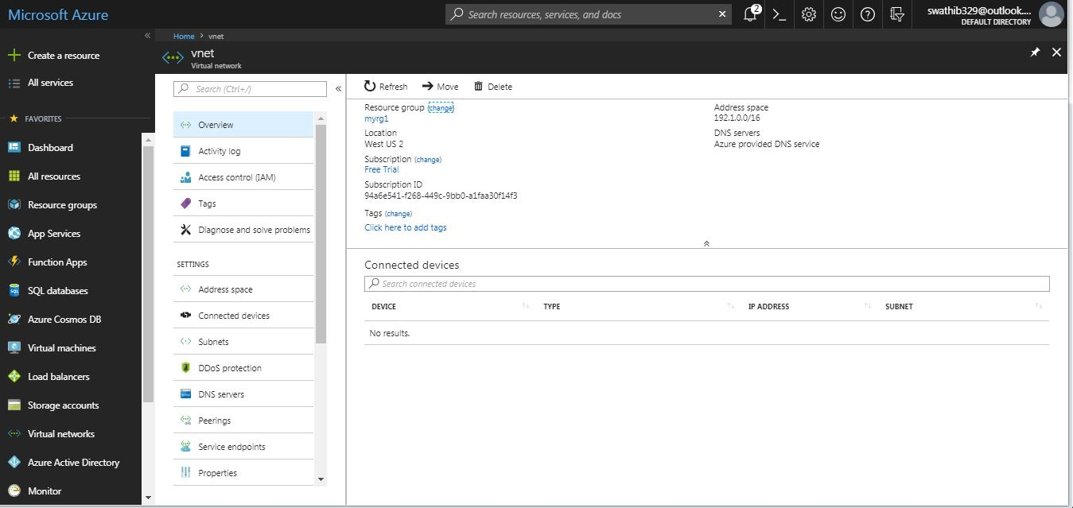

**What is virtual machine?:**

A virtual machine is a computer file, typically called an image, which behaves like an actual computer. In other words, creating a computer within a computer. It runs in a window, much like any other programme, giving the end user the same experience on a virtual machine as they would have on the host operating system itself. The virtual machine is sandboxed from the rest of the system, meaning that the software inside a virtual machine cannot escape or tamper with the computer itself. This produces an ideal environment for testing other operating systems including beta releases, accessing virus-infected data, creating operating system backups and running software or applications on operating systems for which they were not originally intended.

## Create virtual machines

Create two VMs in the virtual network:

### Naming

A virtual machine has a [name](https://docs.microsoft.com/en-us/azure/architecture/best-practices/naming-conventions#naming-rules-and-restrictions?toc=%2fazure%2fvirtual-machines%2fwindows%2ftoc.json) assigned to it and it has a computer name configured as part of the operating system. The name of a VM can be up to 15 characters.

If you use Azure to create the operating system disk, the computer name and the virtual machine name are the same. If you [upload and use your own image](https://docs.microsoft.com/en-us/azure/virtual-machines/windows/upload-generalized-managed) that contains a previously configured operating system and use it to create a virtual machine, the names can be different. We recommend that when you upload your own image file, you make the computer name in the operating system and the virtual machine name the same.

### Locations

All resources created in Azure are distributed across multiple [geographical regions](https://azure.microsoft.com/regions/) around the world. Usually, the region is called **location** when you create a VM. For a VM, the location specifies where the virtual hard disks are stored.

This table shows some of the ways you can get a list of available locations.

| **Method** | **Description** |
| --- | --- |
| Azure portal | Select a location from the list when you create a VM. |
| Azure PowerShell | Use the [Get-AzureRmLocation](https://docs.microsoft.com/en-us/powershell/module/azurerm.resources/get-azurermlocation) command. |
| REST API | Use the [List locations](https://docs.microsoft.com/rest/api/resources/subscriptions#Subscriptions_ListLocations) operation. |
| Azure CLI | Use the [az account list-locations](https://docs.microsoft.com/cli/azure/account?view=azure-cli-latest" \l "az_account_list_locations) operation. |

### VM size

The [size](https://docs.microsoft.com/en-us/azure/virtual-machines/windows/sizes?toc=%2fazure%2fvirtual-machines%2fwindows%2ftoc.json) of the VM that you use is determined by the workload that you want to run. The size that you choose then determines factors such as processing power, memory, and storage capacity. Azure offers a wide variety of sizes to support many types of uses.

Azure charges an [hourly price](https://azure.microsoft.com/pricing/details/virtual-machines/windows/) based on the VM’s size and operating system. For partial hours, Azure charges only for the minutes used. Storage is priced and charged separately.

### VM Limits

Your subscription has default [quota limits](https://docs.microsoft.com/en-us/azure/azure-subscription-service-limits) in place that could impact the deployment of many VMs for your project. The current limit on a per subscription basis is 20 VMs per region. Limits can be raised by [filing a support ticket requesting an increase](https://docs.microsoft.com/en-us/azure/azure-supportability/resource-manager-core-quotas-request)

### Operating system disks and images

Virtual machines use [virtual hard disks (VHDs)](https://docs.microsoft.com/en-us/azure/virtual-machines/windows/about-disks-and-vhds?toc=%2fazure%2fvirtual-machines%2fwindows%2ftoc.json) to store their operating system (OS) and data. VHDs are also used for the images you can choose from to install an OS.

Azure provides many [marketplace images](https://azure.microsoft.com/marketplace/virtual-machines/) to use with various versions and types of Windows Server operating systems. Marketplace images are identified by image publisher, offer, sku, and version (typically version is specified as latest). Only 64-bit operating systems are supported. For more information on the supported guest operating systems, roles, and features, see [Microsoft server software support for Microsoft Azure virtual machines](https://support.microsoft.com/help/2721672/microsoft-server-software-support-for-microsoft-azure-virtual-machines).

This table shows some ways that you can find the information for an image.

| **Method** | **Description** |
| --- | --- |
| Azure portal | The values are automatically specified for you when you select an image to use. |
| Azure PowerShell | [Get-AzureRMVMImagePublisher](https://docs.microsoft.com/powershell/resourcemanager/azurerm.compute/v2.5.0/get-azurermvmimagepublisher) -Location "location" [Get-AzureRMVMImageOffer](https://docs.microsoft.com/powershell/resourcemanager/azurerm.compute/v2.5.0/get-azurermvmimageoffer) -Location "location" -Publisher "publisherName" [Get-AzureRMVMImageSku](https://docs.microsoft.com/en-us/powershell/module/azurerm.compute/get-azurermvmimagesku) -Location "location" -Publisher "publisherName" -Offer "offerName" |
| REST APIs | [List image publishers](https://docs.microsoft.com/rest/api/compute/platformimages/platformimages-list-publishers) [List image offers](https://docs.microsoft.com/rest/api/compute/platformimages/platformimages-list-publisher-offers) [List image skus](https://docs.microsoft.com/rest/api/compute/platformimages/platformimages-list-publisher-offer-skus) |
| Azure CLI | [az vm image list-publishers](https://docs.microsoft.com/cli/azure/vm/image?view=azure-cli-latest#az_vm_image_list_publishers) --location "location" [az vm image list-offers](https://docs.microsoft.com/cli/azure/vm/image?view=azure-cli-latest#az_vm_image_list_offers) --location "location" --publisher "publisherName" [az vm image list-skus](https://docs.microsoft.com/cli/azure/vm?view=azure-cli-latest#az_vm_list_skus) --location "location" --publisher "publisherName" --offer "offerName" |

You can choose to [upload and use your own image](https://docs.microsoft.com/en-us/azure/virtual-machines/windows/upload-generalized-managed#upload-the-vhd-to-your-storage-account) and when you do, the publisher name, offer, and sku aren’t used.

### Extensions

VM [extensions](https://docs.microsoft.com/en-us/azure/virtual-machines/windows/extensions-features?toc=%2fazure%2fvirtual-machines%2fwindows%2ftoc.json) give your VM additional capabilities through post deployment configuration and automated tasks.

These common tasks can be accomplished using extensions:

* **Run custom scripts** – The [Custom Script Extension](https://docs.microsoft.com/en-us/azure/virtual-machines/windows/extensions-customscript?toc=%2fazure%2fvirtual-machines%2fwindows%2ftoc.json) helps you configure workloads on the VM by running your script when the VM is provisioned.
* **Deploy and manage configurations** – The [PowerShell Desired State Configuration (DSC) Extension](https://docs.microsoft.com/en-us/azure/virtual-machines/windows/extensions-dsc-overview?toc=%2fazure%2fvirtual-machines%2fwindows%2ftoc.json) helps you set up DSC on a VM to manage configurations and environments.
* **Collect diagnostics data** – The [Azure Diagnostics Extension](https://docs.microsoft.com/en-us/azure/virtual-machines/windows/extensions-diagnostics-template?toc=%2fazure%2fvirtual-machines%2fwindows%2ftoc.json) helps you configure the VM to collect diagnostics data that can be used to monitor the health of your application.

### Related resources

The resources in this table are used by the VM and need to exist or be created when the VM is created.

| **Resource** | **Required** | **Description** |
| --- | --- | --- |
| [Resource group](https://docs.microsoft.com/en-us/azure/azure-resource-manager/resource-group-overview) | Yes | The VM must be contained in a resource group. |
| [Storage account](https://docs.microsoft.com/en-us/azure/storage/common/storage-create-storage-account) | Yes | The VM needs the storage account to store its virtual hard disks. |
| [Virtual network](https://docs.microsoft.com/en-us/azure/virtual-network/virtual-networks-overview) | Yes | The VM must be a member of a virtual network. |
| [Public IP address](https://docs.microsoft.com/en-us/azure/virtual-network/virtual-network-ip-addresses-overview-arm) | No | The VM can have a public IP address assigned to it to remotely access it. |
| [Network interface](https://docs.microsoft.com/en-us/azure/virtual-network/virtual-network-network-interface) | Yes | The VM needs the network interface to communicate in the network. |
| [Data disks](https://docs.microsoft.com/en-us/azure/virtual-machines/windows/attach-managed-disk-portal?toc=%2fazure%2fvirtual-machines%2fwindows%2ftoc.json) | No | The VM can include data disks to expand storage capabilities. |

### Create the first VM

1. Select **+ Create a resource** found on the upper, left corner of the Azure portal.

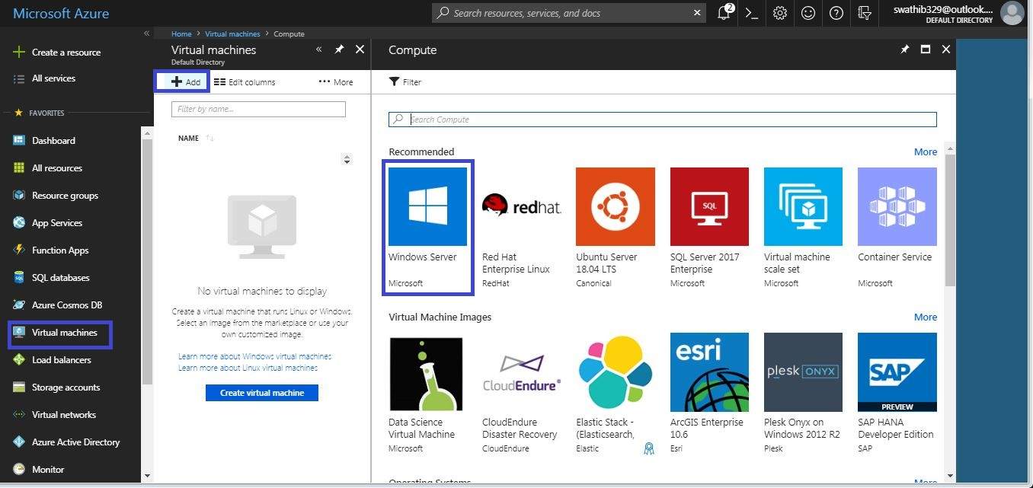

1. Select **Compute**, and then select **Windows Server 2016 Datacenter**.
2. Enter, or select, the following information, accept the defaults for the remaining settings, and then select **OK**:

| **Settings** | **Value** |
| --- | --- |
| Name | Vm1 |
| User name | Msr |
| Password | \*\*\*\*\*\*\*\*\*\*\* |
| Subscription | Free Trail Account. |
| Resource group | Select **Use existing** and select **myrg1**. |
| Location | Select **WEST US2.** |

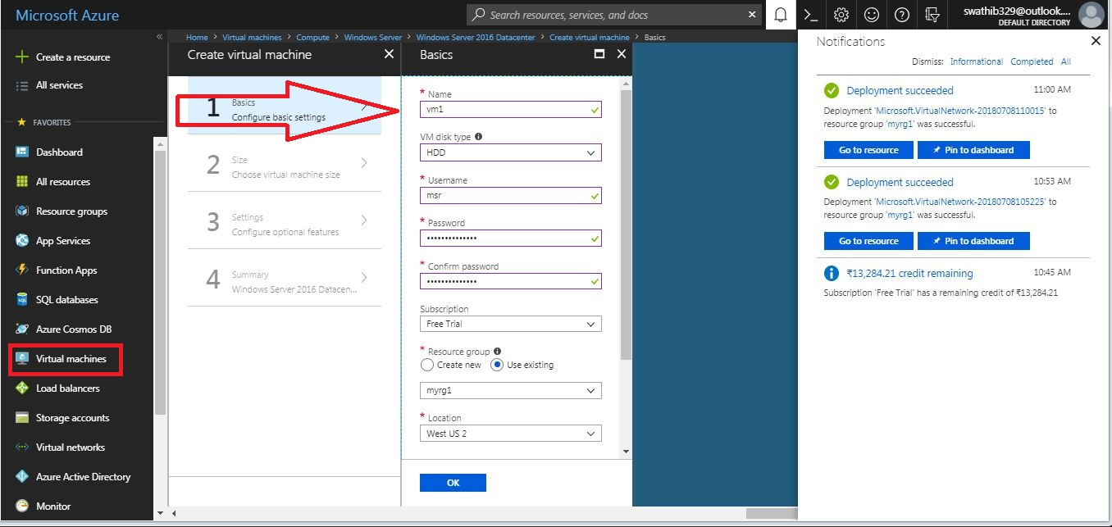

1. Select a size for the VM and then select **Select**.

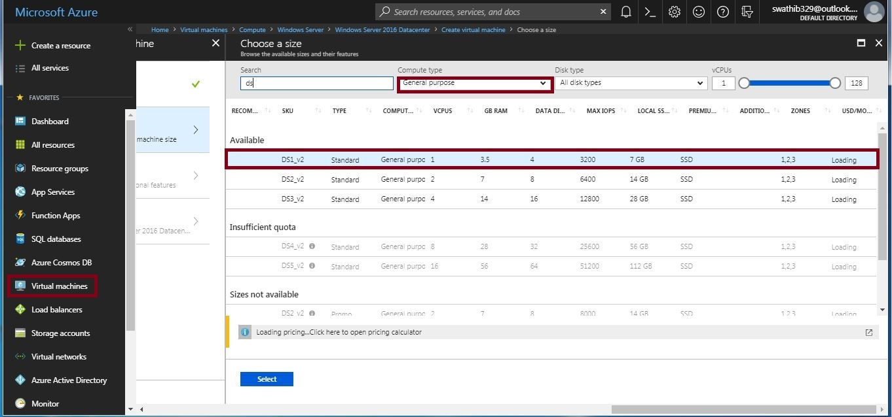

5.Under **Settings**, accept all the defaults and then select **OK**.

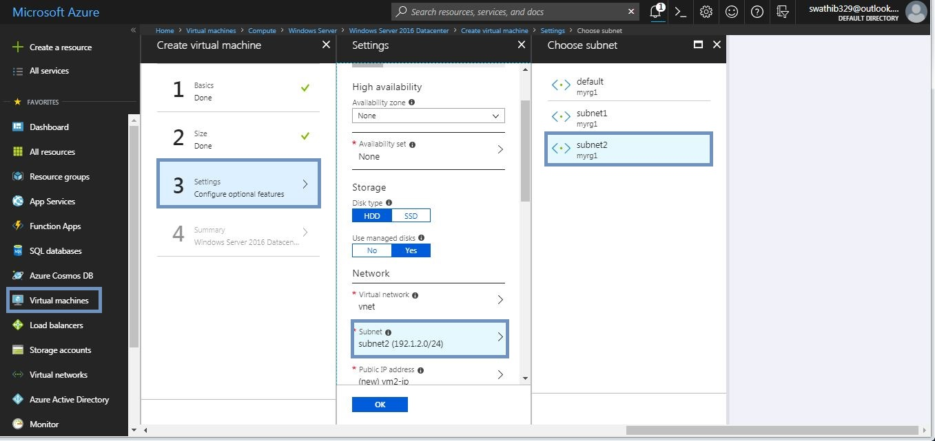

1. Under **Create** of the **Summary**, select **Create** to start VM deployment. The VM takes a few minutes to deploy.

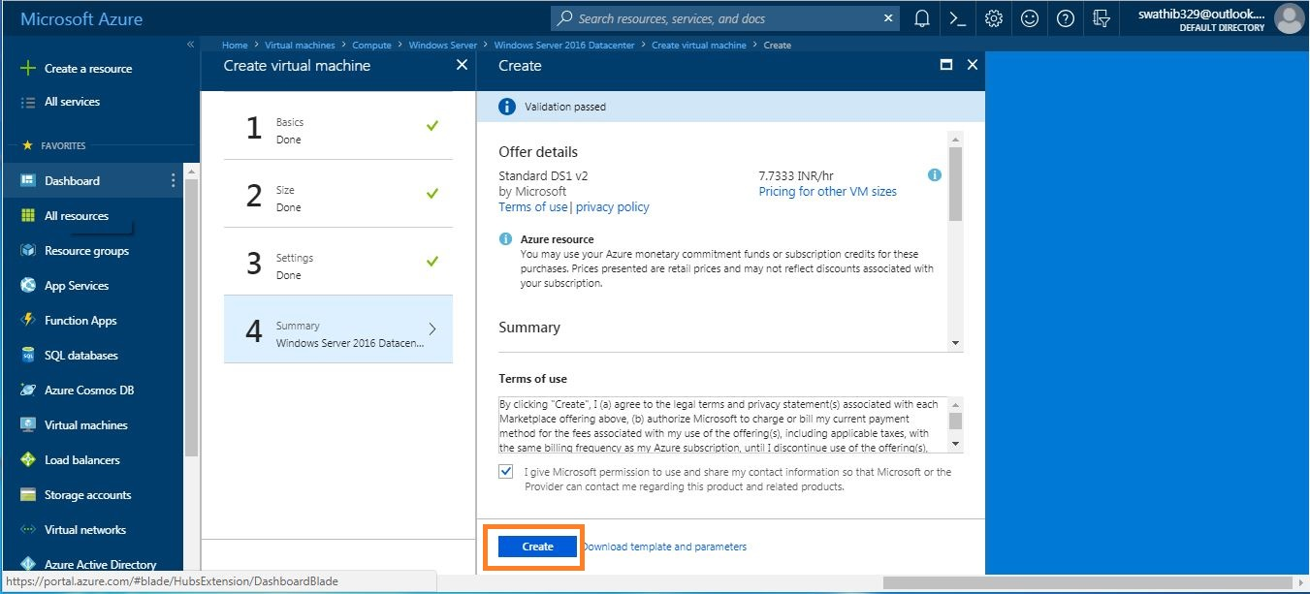

6.After deployment, machine is created and below depicts the views of machine **vm1.**

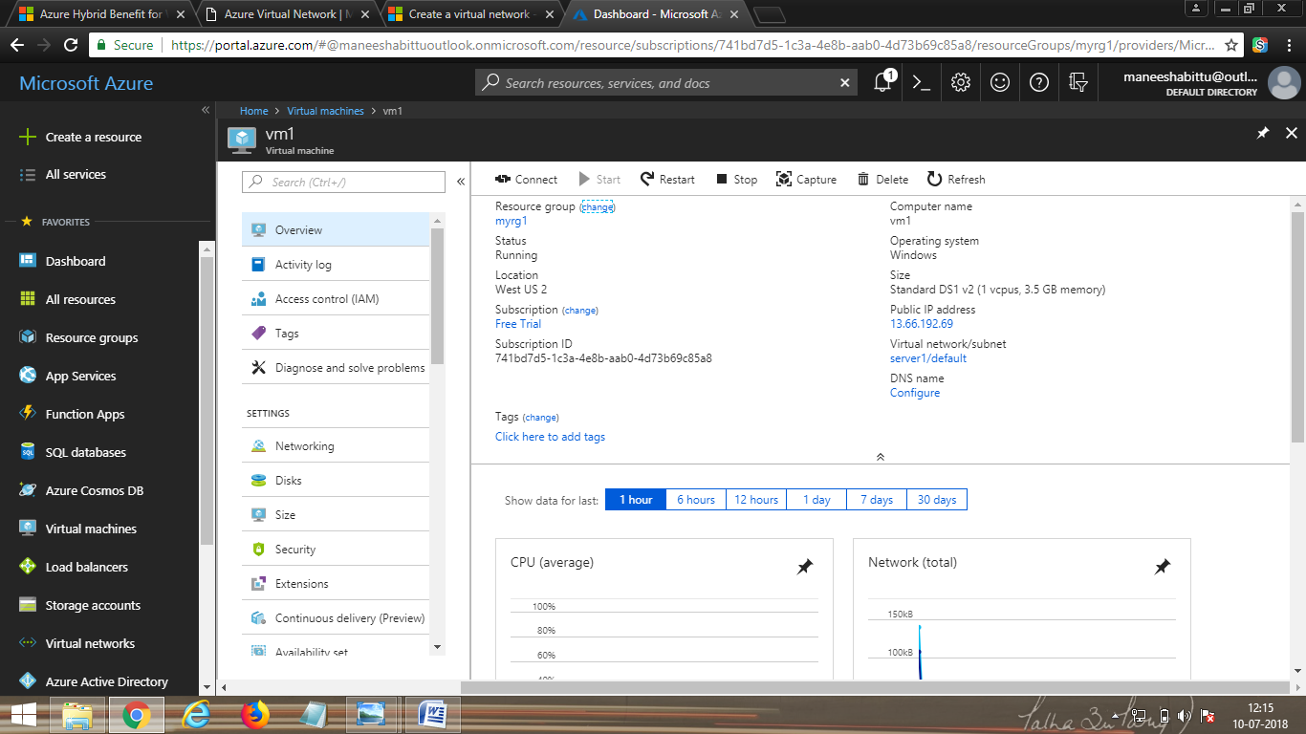

### Create the second VM

1. Select **+ Create a resource** found on the upper, left corner of the Azure portal.



1. Select **Compute**, and then select **Windows Server 2016 Datacenter**.
2. Enter, or select, the following information, accept the defaults for the remaining settings, and then select **OK**:

| **Settings** | **Value** |
| --- | --- |
| Name | Vm2 |
| User name | Msr |
| Password | \*\*\*\*\*\*\*\*\*\*\* |
| Subscription | Free Trail Account. |
| Resource group | Select **Use existing** and select **myrg1**. |
| Location | Select **WEST US2.** |

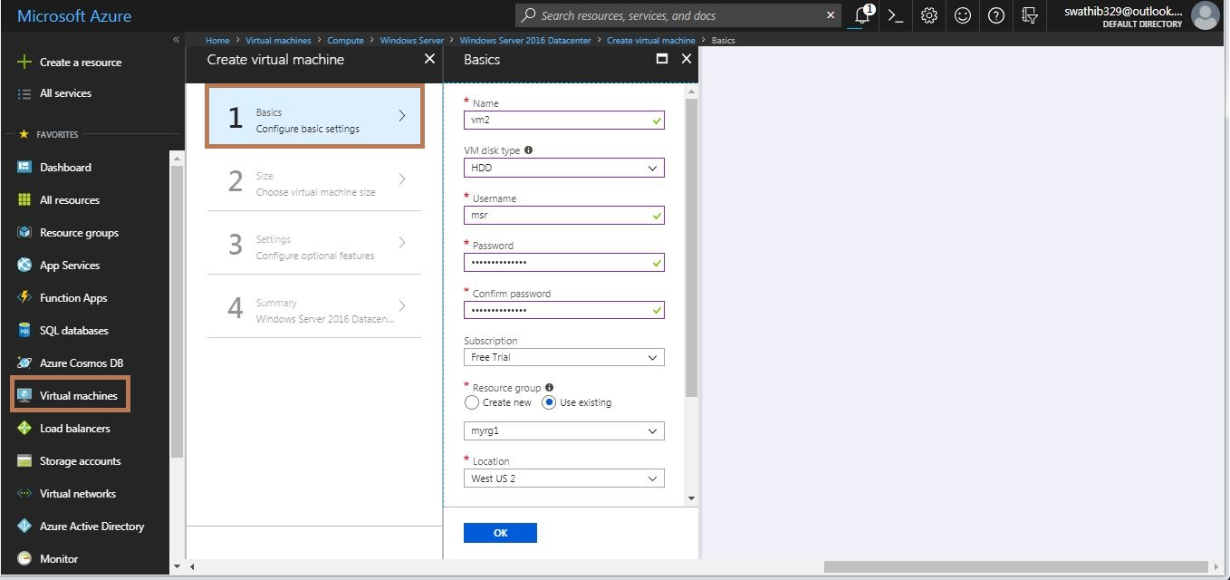

1. Select a size for the VM and then select **Select**.



5.Under **Settings**, accept all the defaults and then select **OK**.



1. Under **Create** of the **Summary**, select **Create** to start VM deployment. The VM takes a few minutes to deploy.



6.After deployment, machine is created and below depicts the views of machine **vm2**

**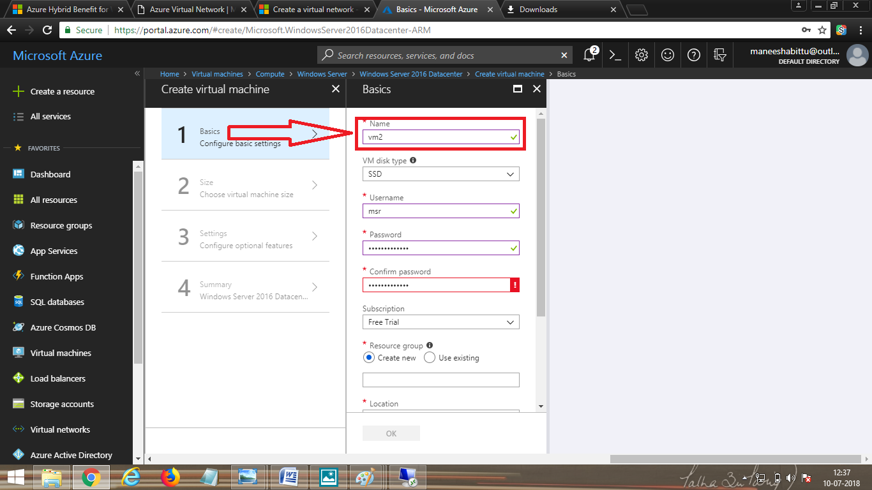**

**Virtual machine vm2 is created.**

**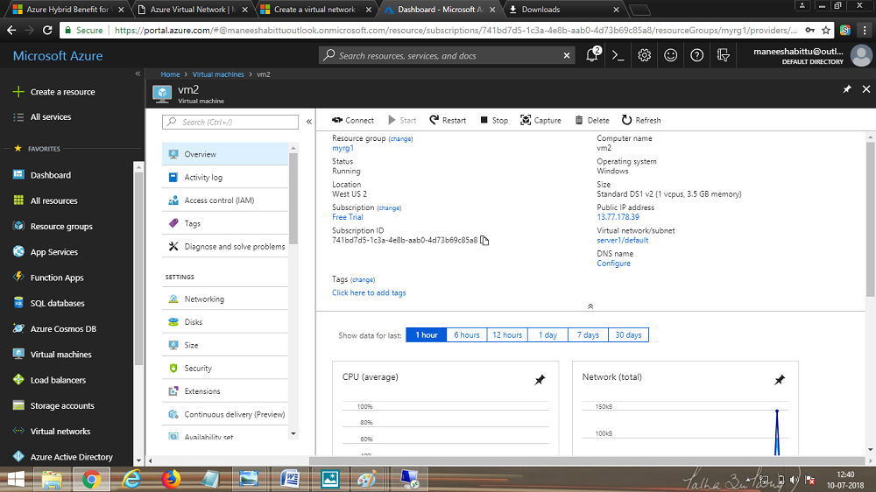**

## Connect to a VM from the internet

1. After Vm1 is created, connect to it. At the top of the Azure portal, enter myVm1. When **Vm1** appears in the search results, select it. Select the **Connect** button.

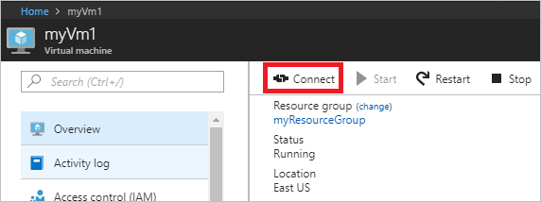

1. After selecting the **Connect** button, a Remote Desktop Protocol (.rdp) file is created and downloaded to your computer.

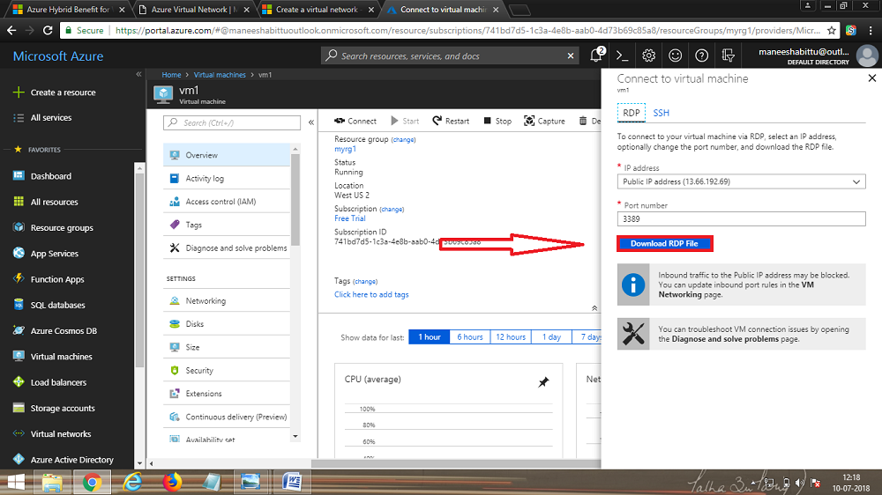

3.Open the downloaded rdp file. If prompted, select **Connect**. Enter the user name and password you specified when creating the VM. You may need to select **More choices**, then **Use a different account**, to specify the credentials you entered when you created the VM.

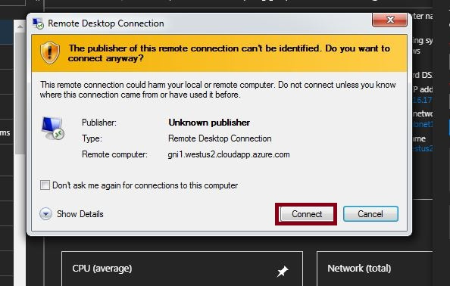

1. Select **OK**.

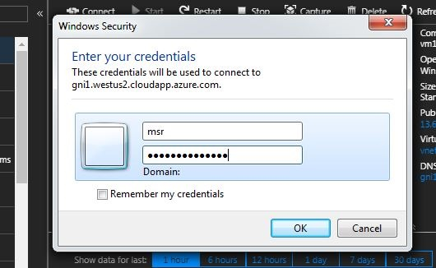

1. You may receive a certificate warning during the sign-in process. If you receive the warning, select **Yes** or **Continue**, to proceed with the connection.

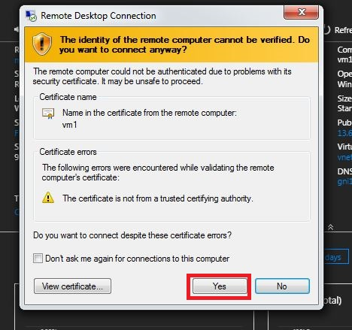

6.Virtual machine vm1 is logged in .

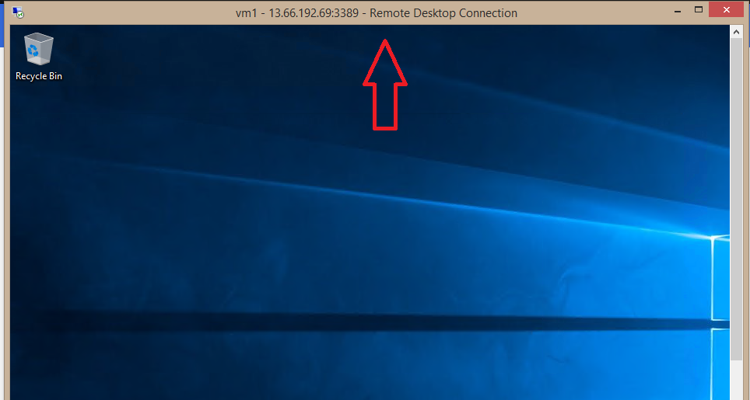

## Connect to a VM from the internet

1. After **Vm2**  is created, connect to it. At the top of the Azure portal, enter Vm1. When **Vm2** appears in the search results, select it. Select the **Connect** button.

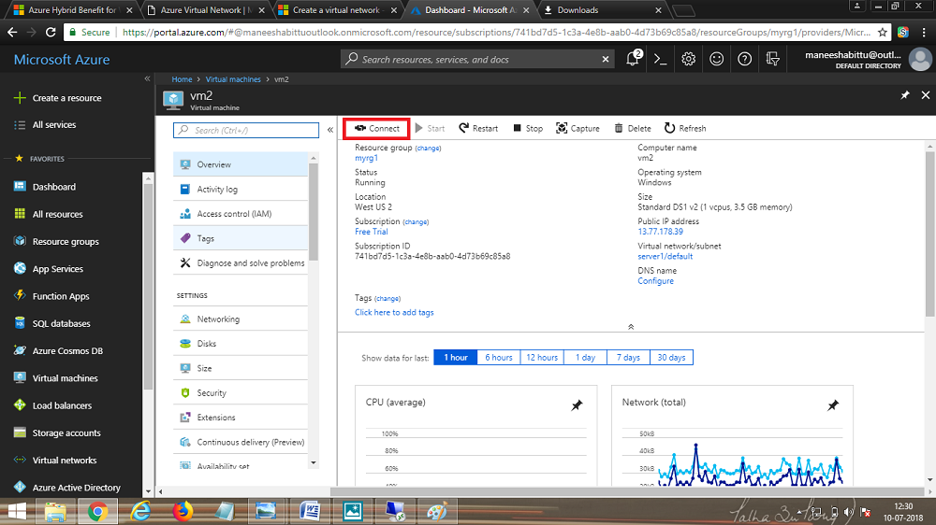

1. After selecting the **Connect** button, a Remote Desktop Protocol (.rdp) file is created and downloaded to your computer.

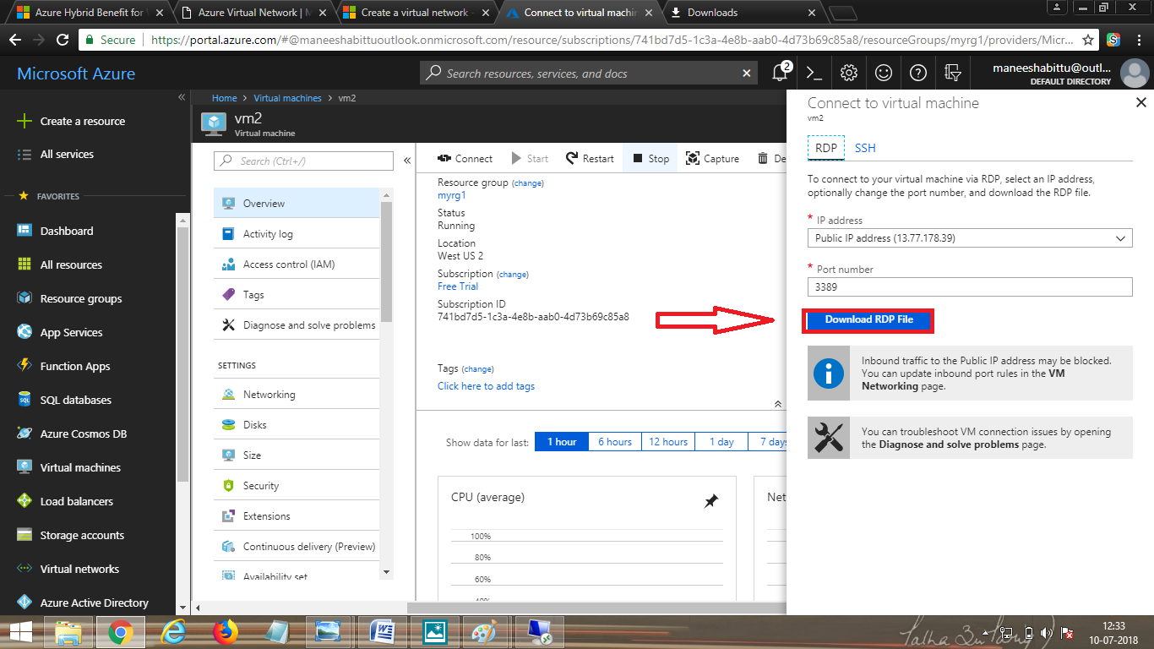

3.Open the downloaded rdp file. If prompted, select **Connect**. Enter the user name and password you specified when creating the VM. You may need to select **More choices**, then **Use a different account**, to specify the credentials you entered when you created the VM.



1. Select **OK**.



1. You may receive a certificate warning during the sign-in process. If you receive the warning, select **Yes** or **Continue**, to proceed with the connection.



This is the view of virtual machine vm2.

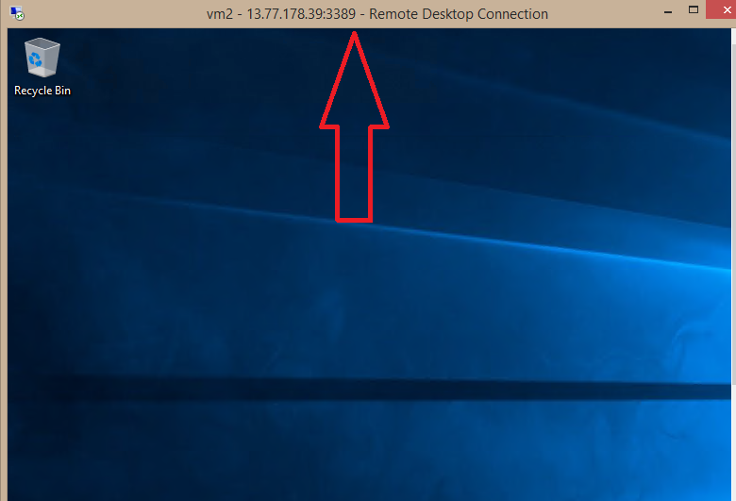

## Communicate between VMs

1. From PowerShell, enter ping vm2. Ping fails, because ping uses the Internet Control Message Protocol (ICMP), and ICMP is not allowed through the Windows firewall, by default.
2. To allow Vm2 to ping Vm1 in a later step, enter the following command from PowerShell, which allows ICMP inbound through the Windows firewall:

PowerShellCopy

New-NetFirewallRule –DisplayName “Allow ICMPv4-In” –Protocol ICMPv4

1. Close the remote desktop connection to myVm1.
2. Complete the steps in [Connect to a VM from the internet](https://docs.microsoft.com/en-us/azure/virtual-network/quick-create-portal#connect-to-a-vm-from-the-internet) again, but connect to Vm2. From a command prompt, enter ping vm1.

You receive replies from Vm1, because you allowed ICMP through the Windows firewall on the Vm1 VM in a previous

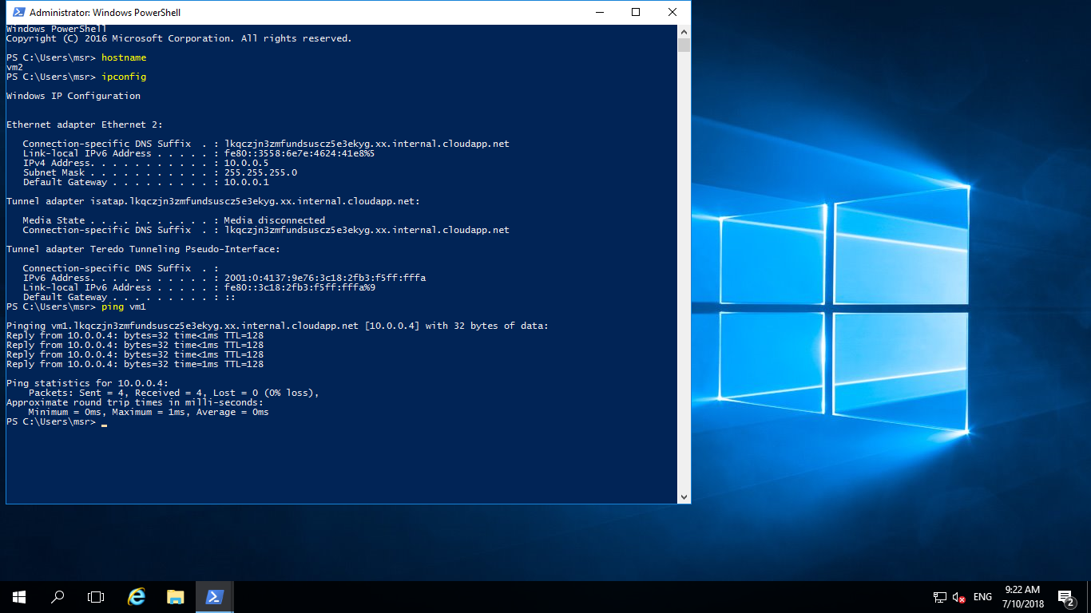

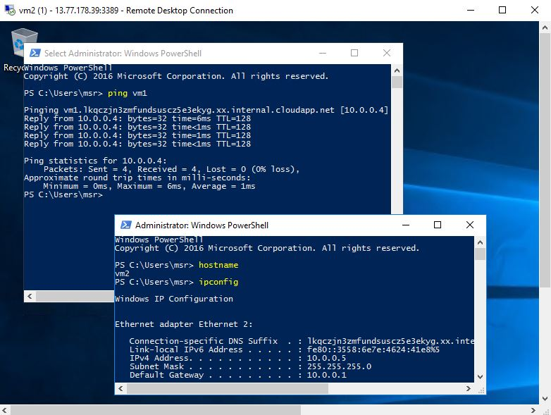

5.Close the remote desktop connection to myVm2.

## Clean up resources

When no longer needed, delete the resource group and all of the resources it contains:

1. Enter myrg1 in the **Search** box at the top of the portal. When you see **myrg1** in the search results, select it.
2. Select **Delete resource group**.
3. Enter myrg1 for **TYPE THE RESOURCE GROUP NAME:** and select **Delete**.